HIGH LEVEL BUSINESS
REQUIRMENT DOCUMENT

CONTRACTOR WEBSITE 1
Asian Paints

Created by
WinkTales

Document Information and Approvals

Version History
Version # | Date |  | Revised By | Reason for change

Table of Contents
1. Document Purpose 1
2. Document Resources 1
3. Glossary of Terms 1
4. Project Overview 1
4.1 Project Overview and Background 1
4.2 Project Dependencies 1
4.3 Stakeholders 2
5. Key Assumptions and Constraints 2
5.1 Key Assumptions and Constraints 2
6. Business Requirements 4

1. Document Purpose

This document defines the high level requirements of Asian Paints contractor Website.

2. Document Resources

Name | Business Unit | Role
Alok John | WinkTales | UX design Head

3. Glossary of Terms

Term/Acronym | Definition

4. Project Overview

4.1 Project Overview and Background
Nil

4.2 Project Dependencies
Nil

4.3 Stakeholders
The following comprises the internal and external stakeholders whose requirements are represented by this document:

 | Stakeholders
1. | Asian Paints
2. | WinkTales
3.

5. Key Assumptions and Constraints

5.1 Key Assumptions and Constraints

# | Assumptions
 | Nil
# | Constraints
 | Nil

6. Business Requirements

6.1 landing page

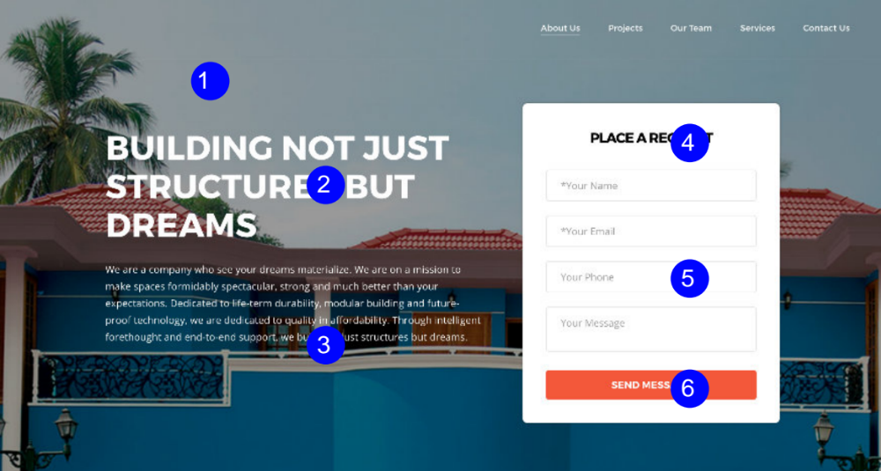

- User flow:
- User will be able fill the form and submit the same
- “Your Name” and “Email” are the mandatory fields in the form, if any of them is not filled, the form is not allowed to be submitted
- When user try to submit the form without filling the “Email” and “Name” the form field should prompt the same.

2. Configurable elements for author:
S.No | Element | Configuration
1 | Landing Page Image | Image Size : 1366 × 514 px
2 | Text | Up to 45 characters including space
3 | Text | Up to 380 characters including space
4 | Text | Up to 15 characters including space
5 | Text | Up to 30 characters including space
6 | Text | Up to 15 characters including space

6.2 About Us
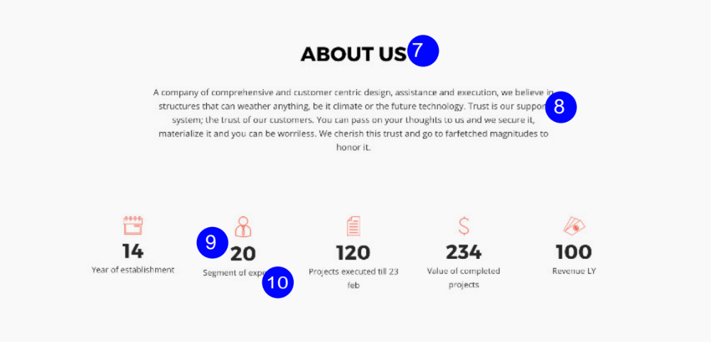

- Configurable elements for author:

S.No | Element | Configuration
7 | Text | Up to 20 characters including space
8 | Text | Up to 400 characters including space
9 | Text | Up to 4 characters without space
10 | Text | Up to 30 characters without space

6.3 Our Team
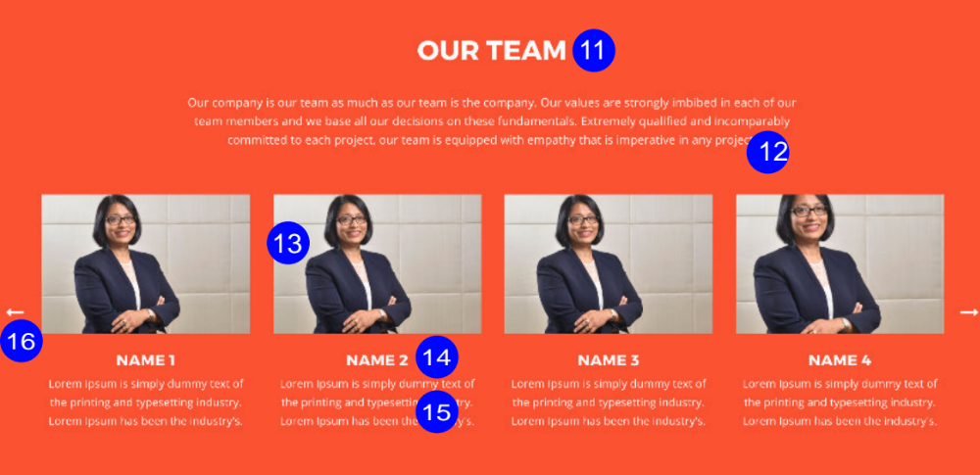
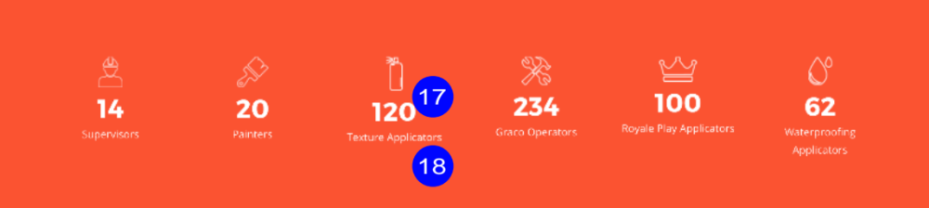

- User flow:

- When a user places the mouse pointer over the picture, it will zoom in. When the mouse pointer is removed it will zoom out for each section.
- User will be able to see other team number by clicking the next button

2. Configurable elements for author:
S.No | Element | Configuration
11 | Text | Up to 20 characters including space
12 | Text | Up to 350 characters including space
13 | Team Image | Image Size : 650 × 434 Px
14 | Text | Up to 15 characters including space
15 | Text | Up to 150 characters including space
16 | Next button | Arrows on both side to scroll next
17 | Text | Up to 4 characters without space
18 | Text | Up to 30 characters without space

6.4. Services

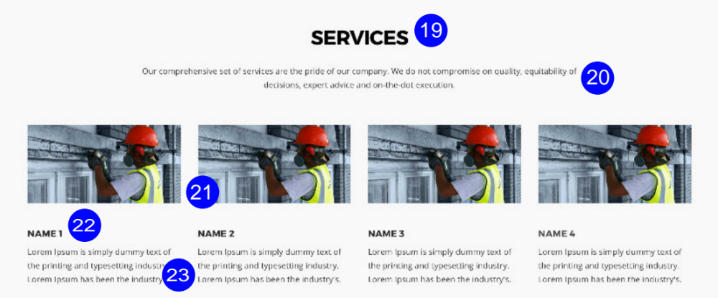
- User flow:
- When a user places the mouse pointer over the picture, it will zoom in. When the mouse pointer is removed it will zoom out for each section.

2. Configurable elements for author:
S.No | Element | Configuration
19 | Text | Up to 20 characters including space
20 | Text | Up to 200 characters including space
21 | Service Image | Image Size : 650 × 434 Px
22 | Text | Up to 15 characters including space
23 | Text | Up to 110 characters including space

6.5. On Going Projects

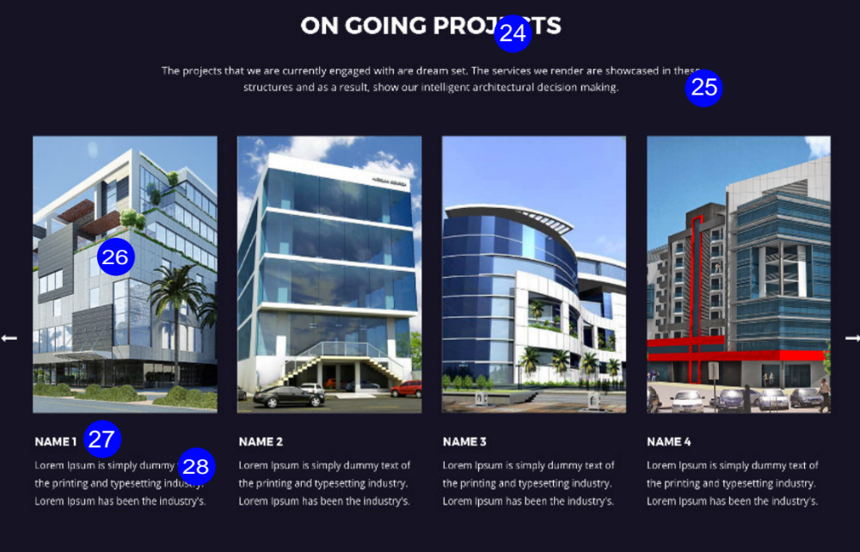

- User flow:

- User should be able to click any of the on-going project image and it should open another window showcasing the project in a bigger view
- User should be able to click next and previous and view the projects in bigger view format
- User should be able to close the bigger view by clicking the close button at the top end right

2. Configurable elements for author:
S.No | Element | Configuration
24 | Text | Up to 20 characters including space
25 | Text | Up to 200 characters including space
26 | Project Image | Image Size : 667 × 1000 Px
27 | Text | Up to 15 characters including space
28 | Text | Up to 110 characters including space

6.6. On Going Projects

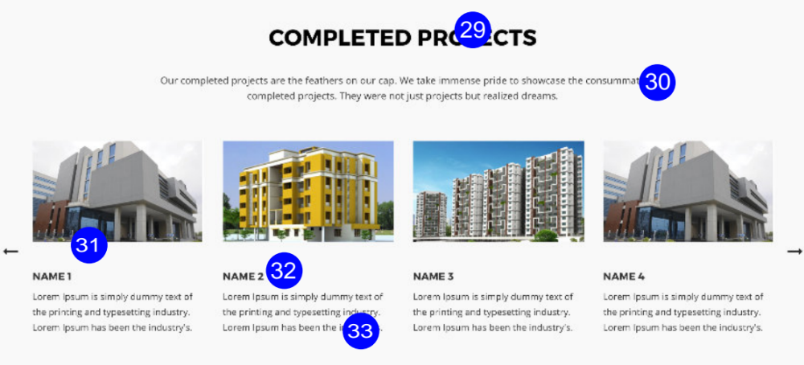

- User flow:

- User should be able to click any of the on-going project image and it should open another window showcasing the project in a bigger view
- User should be able to click next and previous and view the projects in bigger view format
- User should be able to close the bigger view by clicking the close button at the top end right

2. Configurable elements for author:
S.No | Element | Configuration
29 | Text | Up to 20 characters including space
30 | Text | Up to 200 characters including space
31 | Project Image | Image Size : 455 × 268 Px
32 | Text | Up to 15 characters including space
33 | Text | Up to 110 characters including space

6.7. Testimonial

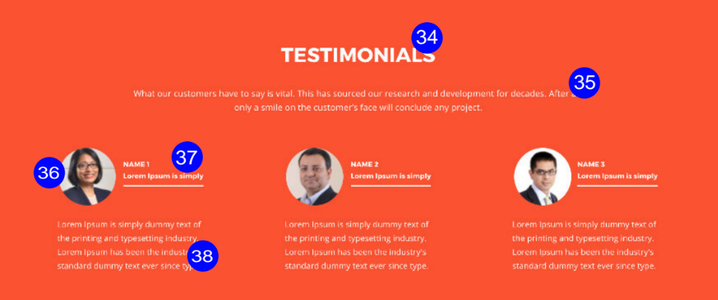

1. Configurable elements for author:
S.No | Element | Configuration
34 | Text | Up to 20 characters including space
35 | Text | Up to 200 characters including space
36 | Testimonial Image | Image Size : 70 × 70 Px
37 | Text | First Line :Up to 15 characters including space  Second Line :Up to 21 characters including space
38 | Text | Up to 110 characters including space

6.8. Our Services

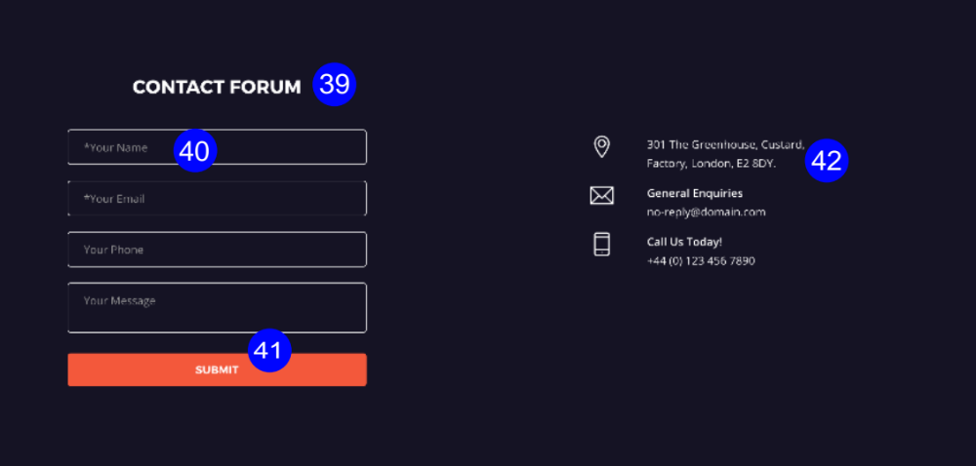

- User flow:
- User will be able fill the form and submit the same
- “Your Name” and “Email” are the mandatory fields in the form, if any of them is not filled, the form is not allowed to be submitted
- When user try to submit the form without filling the “Email” and “Name” the form field should prompt the same.

2. Configurable elements for author:
S.No | Element | Configuration
39 | Text | Up to 20 characters including space
40 | Text | Up to 30 characters including space
41 | Text | Up to 15 characters including space
42 | Text | First Line : Up to 70 characters including space  Second Line : Up to 70 characters including space  Third Line : Up to 70 characters including space

WWW.WINKTALES.COM

